Jessica Martin
10/13/14
App: Paper
By Fifty-three

PROS
- Can create anything!
- Has different tools to work with.
- Allows the work to be exported to camera on device, email, or another app.
- Unlimited amount of new projects one can create.
- Really easy to use!
- App is free.

CONS
- Only comes with one free calligraphy-writing tool.
- One must purchase other tools in order to add different media to.
- There is a special stylus you can purchase for better results, very pricey.
- Only gives six options for color without the mixer tool.
- Can’t change the sizing for writing.

Paper by Fifty-three App Review
After looking up different art apps on my Ipad, I came across an app named Paper by Fifty-three. This app is free to download and can ideally be used to create anything. In the app review description, it states that it can be used for, “sketching, designing, drafting a kitchen model, outlining a business plan”. With such a variety of idea uses, anyone can easily implement this app to whatever project they need to create. The app gives you four folders: Making paper, Ideas, Sketches, and Journals, each folder having a different purpose. The making paper allows the user to view multiple examples on how the app can be used to create different projects. The Ideas, sketches, and journal folders are pretty much there for those exact reasons for the user to put, draw, write their ideas in the Idea folder, to sketch some drawings, and lastly the Journal is for writing but also gives the sketching options. The user is able to add more pages to each of these individual folders as well as making more folders. Each page that is open shows the available features which are all boxed and available for each folder. The free features that are offered are a calligraphy pen, eraser, and 6 different colors. However, the other features that are offered are each $1.99 or the user can by all of the features for $6.99. The features one must purchase are a sketching pencil, an outline marker, an ink pen, a paintbrush, and the mixer palette that allows the user to create different colors. The company Fifty-Three also offers a hand crafted Bluetooth smart stylus that looks like a pencil. It is usb chargeable and comes into prices depending from what matter it was made. The Walnut hardwood stylus is $59.95 and the Graphite aluminum stylus is $49.95. The app can easily be used without the stylus, however, with the styles there is a better result and it is an easier way to draw and erase due to the dual command tip that it offers.
The app is fairly easy and basic because the minute you open the app for the first time it explains that you can: draw, sketch, outline, write and color. Then with the pencil, the user is able to add surface pressure, erase, blend, and has palm rejection. It also explains that better outcome comes from their Bluetooth Smart Stylus. Immediately after the three small introduction slide, the user is able to explore and use the app freely. As stated above the app is extremely easy to use, however, if a user does have any difficulty with the app, they can go onto there account information and click on Support. Under support the app explains the different features and how to use them. Unfortunately, the app does not give any videos for the visual learners on how to use the app, but the information supplied in the support section does give sufficient information needed to use the app. I believe that this product would not give a user any problems learning how to use it and the user would not take more than 10-15 minutes familiarizing themselves and learning how to use it.
The numerous projects that can be created by using this app are quite extravagant because this can be used with any lesson plan that is linked to art. This can be used as the drafting process to any project to jot down ideas, it can be a form of learning different terms or mediums, or it can even be used as a first step to a project and be exported to a different app or email for further use. The ideal grade level that I would use this with is high school but in all honesty the app is extremely easy that middle school students can easily use this app as well. The high school students can definitely use this app to build their skills at learning different medias in art. This app allows them to do numerous things that a pencil alone wouldn’t. The only problem that can occur is that the student doesn’t save the project or there is no Wi-Fi for the device. Besides these points I believe that any student or user that utilizes this app will have a positive outcome.

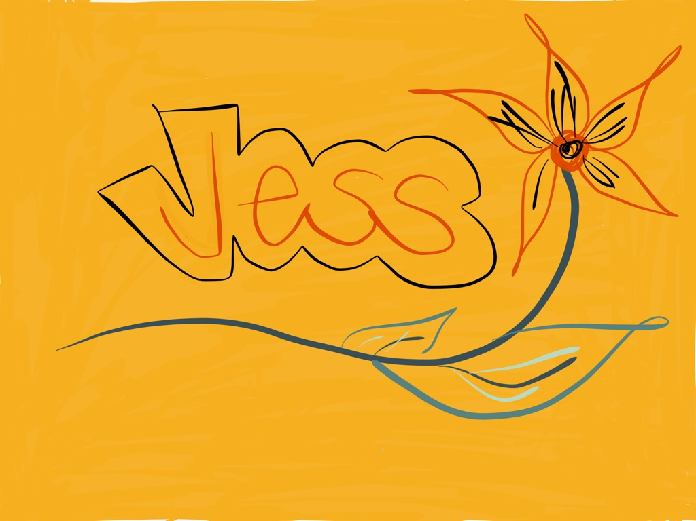
Here is an example of what I drew on the Paper app. My idea to this sample was that students would be able create a nametag and include their name and something they liked.

