Stop Motion How-To
Items Needed for this Project:
- Phone that can download App
- 5-7 personal props to tell Identity story with

To get a good grade students will need to encorperate these elements and priniciples into their Identity Stop Motion film.
Key Elements of Art:
- Space: Pay attention to the fore/middle/background in relation to the areas displayed in your scene
- color: Utilized to create the overall mood of your piece
- Value: Attention to the lighting used while photographing
- Form/Shape: Found objects or drawings that will compose the majority of video

Key Principles of Design:
- Repetition:through repetition of images you will create the illusion of motion
- Harmony: blending different elements together in a well made cohesive fashion
- Contrast: Awareness of the contrast between the foreground and background

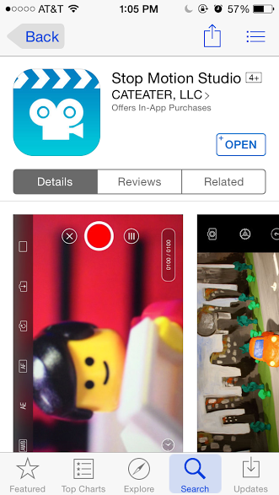
- Download Stop Motion Studio for Apple iphone or download PicPac for Android phone. For the handout I will be using Stop Motion Studio to demonstrate.
- Arrange objects to create desired scene. Remember to keep in mind the elements and principles as you arrange your scenes.
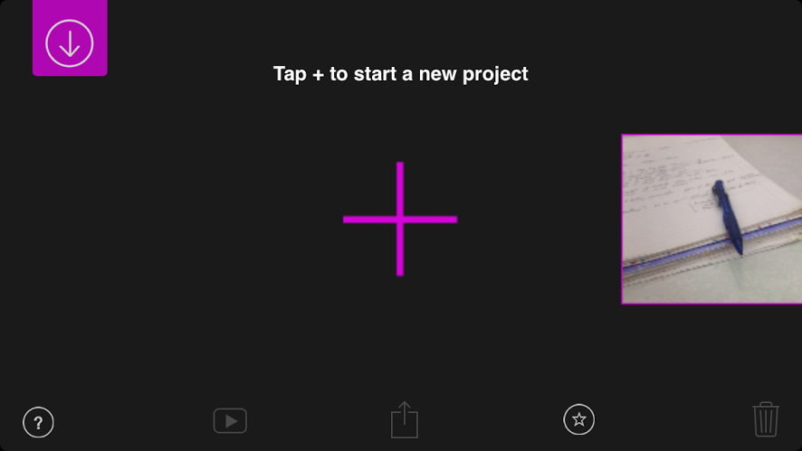
- Capture scene using Stop Motion Studio or PicPac. For Stop Motion Studio press the large cross in the center of the screen.
- Continue to rearrange objects scenes and capture the scenes using your app till you have the needed amount of images to complete your film.
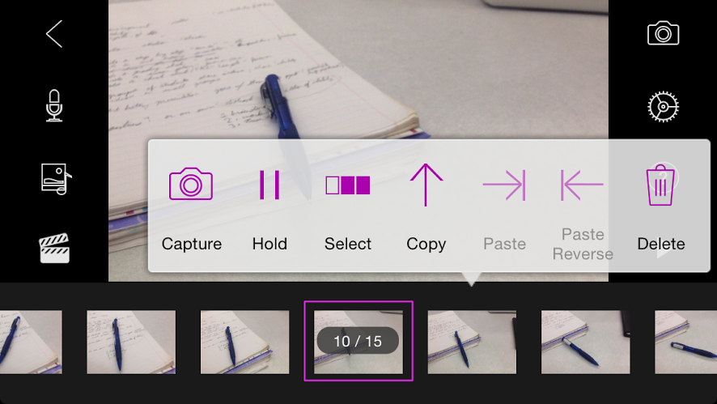
5. Watch the video to make sure it runs smoothly
6. To edit video tap the image once and you will have the option to delete, move, or copy the frame.
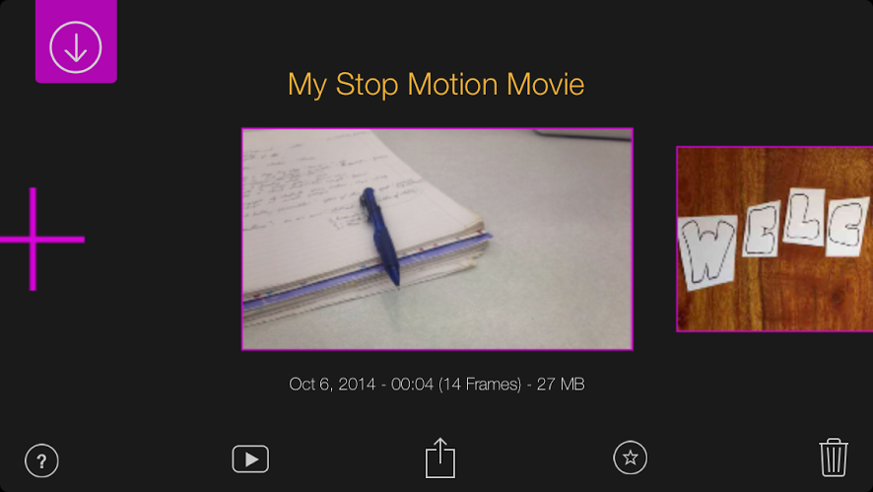

7. Once you are done editing the video upload it by going to My Stop Motion Movie and click the middle button
8. Upload your video to Youtube and paste the link to the class page to turn it in. Don’t forget to watch and comment on your fellow students videos.

